I have a dataset containing family information of married couples, which have around 10 variables & 600+ observations.

Independent variables are ~ gender, age, years married, children, religion etc.

I have one response variable which is number of extra marital affairs.

Now, I want to know what all factor influence the chances of extra marital affair.

Since extra marital affair is a binary variable (either a person will have or not),

so we can fit logistic regression model here to predict the probability of extra marital affair.

install.packages('AER')

data(Affairs,package="AER")

**BUSSINESS PROBLEM:**

**TO CHECK WHAT ALL FACTORS INFLUENCE THE CHANCES OF EXTRA MARITAL**

**AFFAIRS.**

**Summary(affairs)**

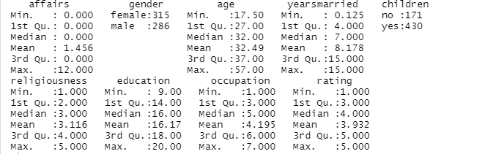

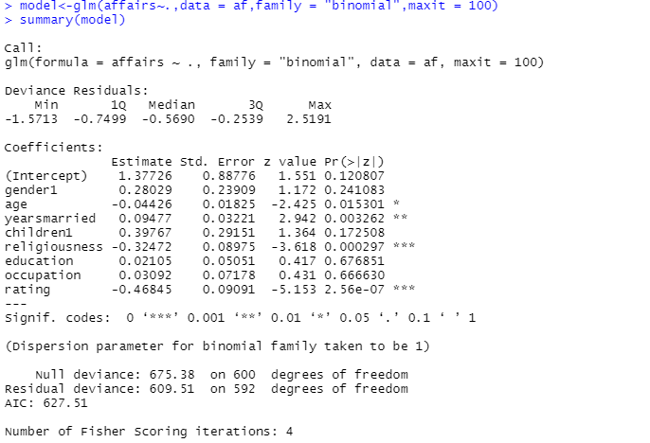

**RESIDUAL DEVIANCE IS LESS THAN NULL DEVIANCE AND DIFFENCE IS LESS**

**IT TELLS THE GOODNESS OF THE MODEL**

> Accuracy<-sum(diag(confusion)/sum(confusion))

> Accuracy

[1] 0.765391

**-ROC CURVE**

**AREA COVERED GIVES THE ABILITY OF BINARY CLASSIFIER**

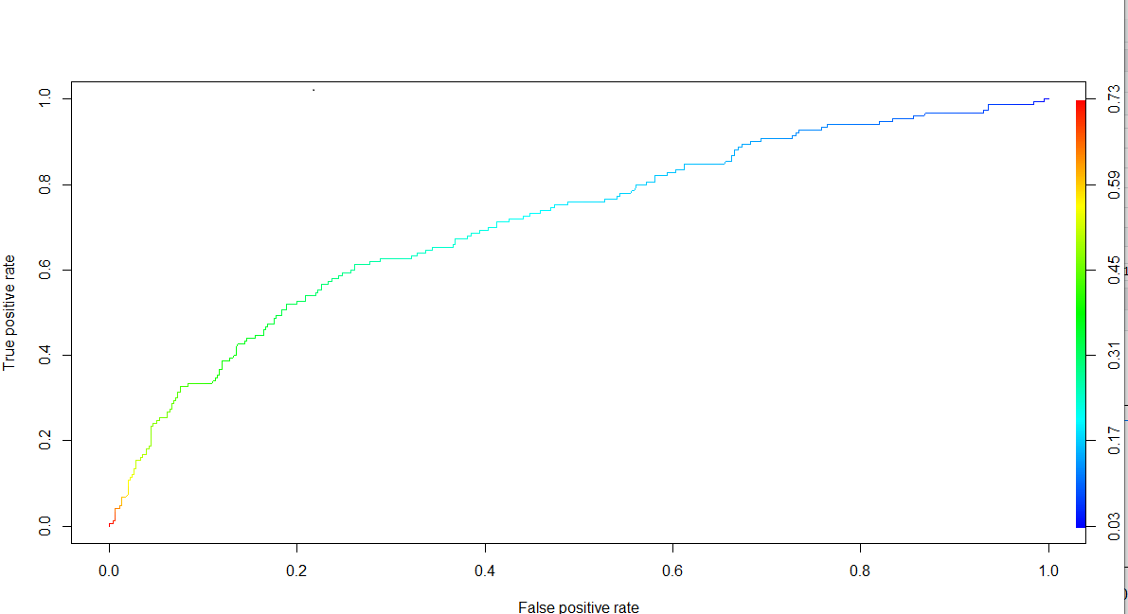**PROBABILITY TABLE**

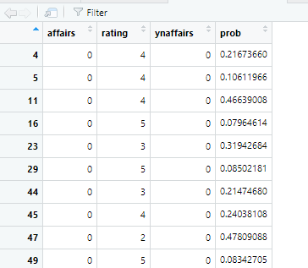

**LIBRARIES USED**

**library(readr)**

**library('AER')**

**library(plyr)**

**library(ROCR)**

**library(dplyr)**

**PYTHON CODE**

**import pandas as pd**

**import numpy as np**

**affairs=pd.read_csv("C:/Users/USER/Desktop/logistic_reg/Affairs.csv")**

**affairs1=affairs.iloc[:,1:]**

**affairs1['naffairs'].values[affairs1['naffairs'] > 1] = 1**

**affairs1.info()**

**affairs1.columns**

**#########train -test**

**x=affairs1.iloc[:,1:]**

**y=affairs1.iloc[:,0]**

**from sklearn.model_selection import train_test_split**

**x_train,x_test,y_train,y_test = train_test_split(x,y,test_size = 0.3)**

**#############**

**from sklearn.linear_model import LogisticRegression**

**model=LogisticRegression()**

**model=model.fit(x,y)**

**###accuracy of training model**

**model.score(x,y)#######accuracy=0.76**

**y.mean()#####only 24% are having affairs**

**###coeff**

**model.coef_**

**np.transpose(model.coef_)**

**#######model validation**

**model1=LogisticRegression()**

**model1=model.fit(x_train,y_train)**

**pred=model1.predict(x_test) ####acc=0.71**

**####probability values**

**prob1=model1.predict_proba(x_test)**

**from sklearn import metrics**

**print(metrics.confusion_matrix(y_test, pred))**

**print(metrics.classification_report(y_test, pred))**

**###predict on train data**

**pred1=model1.predict(x_train)**

**print(metrics.classification_report(y_train,pred1))**

**print(metrics.confusion_matrix(y_train, pred1))###acc=0.79**

**######cross-validation**

**from sklearn.model_selection import cross_val_score**

**score=cross_val_score(LogisticRegression(),x,y,scoring='accuracy',cv=10)**

**print(score)**

**print(score.mean())##avg acc=0.75**